ccSpark Design Document

Version History

Version | Changes | Who/When
1.0 | Document created | C Fisher 1/30/12
1.1 | Edits | A Richards 1/31/12
1.1.1 | Added comments | C Fisher 1/31/12
1.2 | Edits | A Richards 2/2/12
1.3 | Edits | C Fisher 2/3/12
1.3.1 | Added Comments | A Richards 2/16/12
1.4 | Updates, mock-ups added | C Fisher 2/17/12
1.5 | Edits, proofing | A Richards 2/17/12
1.6 | Edits, proofing | C Fisher 2/18

Table of Contents

Version History
Table of Contents
Overview
Target Audience
Curriculum
Prototype Career Information
ccSpark Web Site Features
Homepage
Login System
Registration System
Game: Sparkdale (Grades 3-5 Experience) Overview
Game Flow: Episodes Overview
Game Flow: First Visit
Game Flow: Subsequent Visits
Game Characters
Episodes Overview
Game Leveling
Experience Length
Game: K-2 Experience
SparkCentral
Achievement Badges
Activities
Online Activities
Printable Activities
Parents & Teachers Area
Parents Guide
Teachers Guide
Student Progress Dashboard
Progress Tracking Metrics

Overview
ccSpark! is a Digital Learning Game for elementary students in grades K to 5 that seeks to teach and inspire students about the importance of social skills, life-planning, careers, and various roles in their community. At the heart of ccSpark! is Sparkdale (working title), a role-playing-game that adapts to the child’s curricular needs in an age-appropriate manner. In addition to the online game Sparkdale, ccSpark! provides additional online activities as well as offline classroom and in-home activities that further extend the learning.

Pedagogically, ccSpark! is based on four curricular pillars: lifelong learning, career development, career paths, and personal social interactions. Each of these four pillars is further divided into domain goals, which are discussed in greater detail below. While ccSpark is designed as an educational experience, the primary gaming experience introduces the standards in an engaging and enjoyable way.

Target Audience
ccSpark will be an engaging interactive educational experience that will meet standards for career, educational and counseling guidelines in Canada and the US, including the National Career Development Guidelines (NCDG), American School Counselor Association (ASCA) and Blueprint for Life competencies. The product will be developed for two audiences:

- Audience 1: Grade 3-5
- Audience 2: Grade K-2

Curriculum
At this age, career learning is not about choosing a career but rather about understanding macro life skill concepts, like planning skills or personal awareness. To address this, four content standards comprise the curricular foundation of ccSpark!: personal social interactions; lifelong learning; career development, and career paths.

Each content pillar is divided into domain subsets as follows:
- Personal social: concept of self, social skills, change and growth, and balance
- Lifelong learning: achievement and purpose, participating experiences
- Career development: planning, decision making, using information, skills
- Career paths: health, nature, business, fixing and building, helping, creative

The ccSpark! experience addresses this curricula via the Sparkdale game, online reflection activities, and downloadable offline activities for use in the classroom and at home. (These activities are described below.) Used alone, any one activity provides important educational information. Used together however, the content areas are introduced and reinforced in the following ways:

- In-class activities foster knowledge acquisition.
- Online gameplay (Sparkdale), in which the child serves as a member of the community, fosters the acquisition and application of knowledge.
- In-class and online reflection activities reinforce the learning.

In thoughtfully creating the three types of content, the educational experience of ccSpark! uses a holistic approach, where each element contributes to learning along with the others.

Career Cruising is in discussion with Jacqueline Leighton, Professor and Department Chair, Educational Psychology with the University of Alberta, to formalize the educational framework.

Prototype Career Information
A full list of careers and features is in the ccSpark! Career Document.

For each career, the following information will be presented in gameplay or via SparkCentral to whatever extent possible. For example, if the career is Scientist:
- Definition
  - Scientists study the physical world in order to answer questions about it, include what it’s made of and how it began.
- Core Tasks
  - Develop and test scientific theories
  - Collect and analyze data from experiments
  - Use research to help people or protect the environment
  - Write grant proposals to get funding
  - Prepare reports, research papers, and presentations about their findings
- Workplace (i.e. who employers are, work environment, etc.)
  - Employed by governments, colleges and universities, private companies, research institutes, and other organizations
  - Work indoors in labs and offices, and outdoors in the field
  - Professors teach in classrooms, lecture halls, and labs
  - Most have flexible schedules, but work long hours including evenings and weekends
  - Work with lab techs, students, businesspeople, or other scientists
- Earnings
  - $30,000 to $100,000 a year for most
  - Earnings depend on experience, education, and scientific specialty
- Education & Training
  - At least a bachelor’s degree in a scientific field
  - A master’s degree or PhD is often required for senior and advanced research positions
  - A PhD is required to teach at a university
- Attributes & Abilities
  - Patient
  - Methodical
  - Enjoy working with data and numbers
  - Communication skills
  - Business knowledge is useful for private sector scientists

ccSpark Web Site Features
Features are as follows (and are described in the sections below):
- Login system
- Student features
  - Game: Sparkdale (Grades 3-5 Experience)
  - Game: K-2 Experience
  - SparkCentral
  - Achievement Badges
  - Activities (Online and printable)
- Parents & Teachers Area
  - Parents guide
  - Teachers guide
  - Student Progress Dashboard
- Progress Tracking Metrics

Homepage
UI Question: What screen size are we designing for?

Homepage (not logged in) elements include
- ccSpark logo
- Login widget
  - Need discussion with Cow/CC on how this is going to plug into the existing system.
- Link to teacher info
- Link to parent info
- Are we going to have a demo/guest access for some content?
  - Episode one demo
  - How is it accessed? From homepage?
- How do parents and teachers log in? Different login than child log in?

Figure 1. ccSpark Homepage Mock-Up. User is not logged in. For discussion of features. Not reflective of usability/layout.
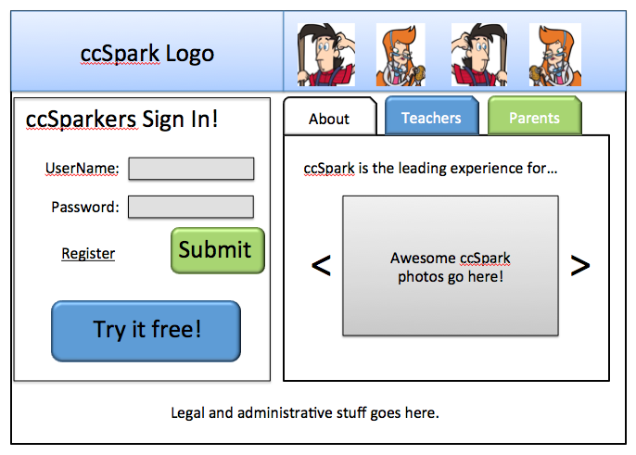

Homepage (logged in). Elements include
- Sparkdale icon
- SparkCentral icon
- Links to activities pages
- Rotating feature box to promote activities

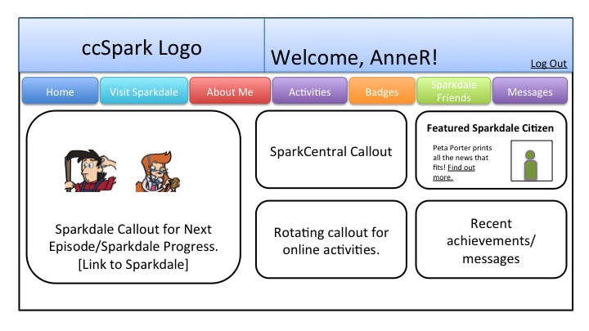

Login System
Integrated with Career Cruising login system.

Under discussion.
- Login system questions
  - COW: What have you found out so far about how the login system is going to link into the CC system? Does the child need to create a username? Is there an existing login for the teacher for the classroom? Or…?
  - Is there a different area for parents and teachers to log in that’s separate from the kids area?
  - Is there a different login system for K-2 and 3-5 as their abilities are different? (I don’t love this as a child could use the site from K on up and be confused when a new system is introduced.) I think the above questions will help guide this.
  - Do parents have a separate login? Or is it seamless on the front end? Everyone logs into the same place?
  - What’s needed on the registration side of things?
    - Are children able to create their own account? Or does a parent/teacher have to do everything?
    - If the parent creates it, how do we support the child forgetting a password?

Registration System
Integrated with Career Cruising login system.

Under discussion.

Game: Sparkdale (Grades 3-5 Experience) Overview
Welcome to Sparkdale! It’s just like your town, only a little more wacky and whimsical. A bustling, idealistic town seen from a kid’s point of view, it’s an ideal place to explore how everyone is a part of a larger community that they contribute to and get something back in return. It’s an explorative world full of appealing characters and places just like the ones kids encounter every day in their own lives and neighborhoods.

When you first arrive in Sparkdale, select your character and add a few personal touches. Then jump into the world and start helping out as an active member of the community.

Students are in for a funny surprise, as they discover that something has gone awry in Sparkdale! The town’s residents have lost their sense of purpose, and everyone’s doing the wrong job -- the doctor is searching in vain for a potato’s heartbeat; the firefighter is breaking in to his office cubicle with an axe; the police officer is giving tickets to anyone who speaks above a whisper in the library; and the teacher is lecturing the plants in the local greenhouse! It’s the player’s job to help sort out the community so that everyone is back to doing what they do best.

As the players explore Sparkdale!, newspaper articles appear and document the progress of the player, e.g. “Simon Smith Helps Doctors Find Hospital!” The intrepid Sparkdale reporter interviews the player via a pseudo-instant-messaging window, prompting the player to reflect on their actions. These interview questions then appear in the newspaper article, which also becomes part of the portfolio chronicling the child’s experience on Sparkdale as well as the larger ccSpark! Web site. Note that the Sparkdale paper only reflects the child’s individual achievements, not those of the classroom. It is not a multi-player experience.

Game Flow: Episodes Overview
Sparkdale’s gameplay is based around episodic missions.

Please see Sparkdale Episode One Mock-Up for a partial example.

Basic Steps for Each Episode

- The child finds out about the problem/goal of the episode (i.e. the player reads about it on the reporter’s blog, the mayor requests the player’s help, etc.).
- Key locations related to the episode are unlocked on the map.
  - Some extra locations, like the Town Center, are always unlocked to provide additional characters and/or red herrings.
- Child visits the locations to collect a target number of clues.
  - Clues are logged in SparkCentral. (See SparkCentral section below.)
- When all clues (or majority of clues, pending design) are unlocked, child can continue to explore or opt to solve the mission.
- The reporter “interviews” the player to ask for a comment, which doubles as a reflection activity.
- A new blog post is available that summarizes the episode.
- After completing the episode, players can review the episode and achievement badges by visiting SparkCentral. Additionally, all characters encountered in the episode become “friends” in SparkCentral, so you can access their information (including career info) at any time.

Episodes Content Plans
[Educational approach and key curricular goals to come. Includes introducing social-emotional learning (e.g. getting along with others), and personal goals (e.g. going back to school to change careers or further learning, etc.)]

Episodes generally fall into one of the following approaches.
- Confused Careers
  - A person has become confused about his job and is doing the wrong thing in the wrong place. Gather the items he needs to return to the proper work location.
  - Target questions
    - What items/objects do these careers use?
    - What kinds of people do these careers work with?
    - What kinds of skills are important for these careers?
- Wreaking Havoc
  - A person has become confused about his job. Travel around Sparkdale and see the confusion caused by the missing person, then help him find his proper place.
  - Target questions
    - What roles does this career play in the community?
    - What kinds of people do these careers interact with?
    - What kinds of skills are important for these careers?
- Finding a Place in Sparkdale
  - A person isn’t sure where he belongs. He has a skill set but doesn’t know quite what to do with it. Help uncover the skills and then match them with a location.
  - Target questions
    - What skills is this person good at?
    - What kinds of jobs could he do?
    - What kinds of skills match with various jobs?
- Missing Position
  - A business is challenged as they’re missing a person. Uncover what kinds of skills they need and interview people to find the right person.
    - Target questions
      - What skills does a business need?
      - What kinds of careers does a business need?
      - What kinds of skills are needed to be part of a team?

Game Flow: First Visit
- Child logs in. (See login system and registration above)
- If child’s first time, child is asked to select an avatar.
- A short sequence of graphic-novel-esque pages explain Sparkdale, who the child’s character is, and what’s going on.
- Leads into episode one, with introductions to how to navigate.

Game Flow: Subsequent Visits
- Child logs in. (See login system and registration above)
- If child was midway through an episode, child is returned to last saved location in game.
  - Note this requires periodic saves of current state. Need to discuss how frequently.
- If child had concluded an episode, go to main area where child can select next challenge.

Game Characters
- Child Avatar
  - A number (TBD) of avatars are available for the child to select.
  - Avatar has a series of expressions for use based on game context
    - Happy
    - Neutral
    - Questioning
    - Sad
    - Celebratory
- Non-Player Characters (NPC)
  - Each NPC represents a career and member of the community
  - Identified by key iconic elements
  - Each individual NPC has a series of poses/expressions for use based on game context
    - Neutral
    - Surprised
    - Celebratory

Episodes Overview
The final number of episodes is estimated at 20. Episode summaries are available in the episode summary document.

Game Leveling
As a large number of careers are addressed in Sparkdale, the career content will be distributed across the grades 3, 4, and 5 experience. In other words, rather than divide the experience into content specific for grades 3, 4, and 5, Sparkdale will feature a series of episodes that increase in difficulty and depth of information.

Additional activities outside the game will target specific grade-appropriate curriculum goals.

Earlier episodes will
- be written with a slightly simpler reading comprehension and vocabulary (grade 3 target).
- focus on careers with more concrete skills and educational attainment (decided in conjunction with curriculum team).
- begin to introduce locations as complex places with a combination of jobs. For example, hospitals have more than one kind of doctor.
- feature clues that are more concrete and obviously placed around Sparkdale.
- allow badges to be earned more easily.
- feature other grade-appropriate sub-goals as defined by curriculum.

Later episodes will
- use a more difficult reading comprehension and vocabulary (grade 5 target).
- feature more jobs within each episode, including jobs that are more difficult to understand.
- hide clues in less obvious places.
- require more steps to earn a badge.
- feature other grade-appropriate sub-goals as defined by curriculum.

Experience Length
Individual episodes should last approximately 10 minutes of gameplay (as part of an overall 15-20 minutes of ccSpark experience). Later episodes may require two sessions.

Students may play ccSpark repeatedly over several school years.

Game: K-2 Experience
TBD
Younger students (grades K to 2) complete small missions in which they help others get their jobs done. For example, they might deliver bandages to the hospital to assist Sparkdale’s family doctor or help pick vegetables with town’s resident farmer.

SparkCentral
SparkCentral is the child’s clearinghouse of everything he’s accomplished on ccSpark, from game progress to activities completed. In many ways, it is the meta-game that surrounds the entire ccSpark experience.

SparkCentral is always available, regardless of whether the child is in the midst of a Sparkdale episode or is completing one of the other activities. In other words, it is separate from the game, but hosts information gathered in the game as well as from other activities on the site.

Information includes
- Profiles of all the characters met in game
  - Clues, and other bits of information that has been gathered
  - Basic stats and profile info that are not included in game but are important
- Headlines and experiences from episodes of the Sparkdale game
- Child’s SparkCentral progress, activities, etc
  - Results from various quizzes and activities (outside Sparkdale)
  - Details of achievement badges that player has earned
- Other TBD
  - Mini blog where parents and teachers can add comments
  - Graphic assets from the game and reflection activities used to create a “me collage”

Figure 2. SparkCentral Mock Up (Friends page). This is for discussion of features only, not layout/usability.
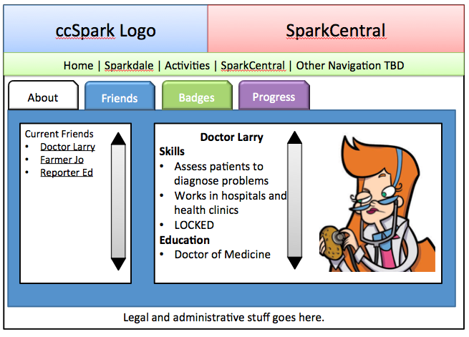

Achievement Badges
Throughout the ccSpark experience, the child can earn badges. Badges will be defined as the gameplay progression and site content is created, but some examples are
- SparkCentral Resident (unlock in episode one)
- Master Communicator (talk to 10 characters in game)
- Quiz Master (take 5 quizzes)
- Medical Master (talk to 5 medical characters in game)
Badges are not always parallel to the linear game experience, but can instead aggregate trends across the game, such as noting when a player has talked to a variety of characters that work in the medical field. This further encourages drawing connections between the various curriculum goals.

Activities
In addition to the concepts introduced in Sparkdale gameplay, a number of activities are built into the ccSpark! Web site. These activities not only further extend the lessons learned in Sparkdale but also fill curriculum areas not addressed in Sparkdale. The activities include online quizzes as well as printable activities for classroom use.

Online Activities
Where logical, these online activities will be extensions of the Sparkdale game, asking children to think about the characters they’ve encountered in the game. Given the curriculum goals, it is not feasible (nor logical) for all activities to be situated within Sparkdale. Thus, some activities will be stand-alone and a child can explore the activities, regardless of their time spent in Sparkdale. This might include online worksheets and quizzes that not only introduce career choices but help the child learn more about themselves.

Sample online activities include:
- Personal Learning Styles quiz. The outcomes of this quiz are also saved to SparkCentral
- Quizzes
- Word Search
- Story Strips
- Blog posts (shared in SparkCentral)

As ccSpark! is designed with a curriculum path in mind, activities will include suggestions and links to other activities to continue the learning.

Printable Activities
Offline activities, designed specifically with the classroom in mind, introduce curriculum concepts as well as allow children to further internalize the ideas. Activities include printable worksheets that encourage reflection and self-discovery. As with the online activities, some will use the child’s experiences with Sparkdale as a way into the activity. However, as the prescribed path of ccSpark! is to introduce the curriculum in the classroom first, many of the activities will be independent of Sparkdale, serving instead to allow children to familiarize themselves with the concepts.

Offline activities can also be used by caregivers at home, often with simple modifications, as described in the Parents’ Guide to ccSpark!

Sample offline activities include
- Reading and Reading Response, Career or Job subject matter - i.e. Archers, Alchemists, and 98 Other Medieval Jobs You Might Have Loved or Loathed, Yang the Eldest and His Odd Jobs (Literacy, History/Social Studies)
- Class newspaper collaborative project - includes a community walk or visit field trip, interviews, writing and assignments (Literacy, Writing and Social Studies)
- About Me Collage – Things I like, feelings I have, what makes me happy etc. (Art)
- Career Paths exercises that demonstrate the differences in kinds of work. i.e. health - class visit from an Ambulance/ teach students about basic first aid; Nature - a community garbage pick up day/planting seeds; business - have a business dress up day/have students use graphs to plot money & orders collected for bake sale etc.; fixing and building - investigate the way things are made/discuss materials; helping - discuss conflict resolution skills/involve students in a community volunteer activity i.e. at a nursing home; creative - have students create a classroom makeover/design school spirit wear.

Activities may be divided into thematic buckets, such as
- What do people do? (Career paths)
- What do I like to do? (About me)
- What did people used to do? (History)
- What are people doing right now? (Current events/news)

Parents & Teachers Area
To further augment the overall experience, resources are available for parents and teachers to extend the learning of the ccSpark! experience, including written content guides for parents and teachers, additional resources, and a progress tracking dashboard.

Parents Guide
TBD

Teachers Guide
ccSpark! has strong educator support content available through the Teachers Guide section. The Teacher Guide prescribes methods to implement ccSpark! into the classroom, including lesson plans, timelines, and curriculum goals, as well as suggestions of how to dovetail these with other learning areas such as art or language.

Student Progress Dashboard
The dashboard assists educators in understanding the child’s progress using learning indicators that are built into the online game. Through this dashboard system, the teacher or caregiver can review the child’s progress including:
- Completion of Sparkdale! game levels
- Personal Assessment completion and outcomes
- Completion of Reflection Activities
- Child`s personal “Portfolio” (might be tied into SparkCentral? Needs more discussion)
- Other progress points as determined during development

The activities and information reported in the dashboard were selected as part of the overall ccSpark! educational evaluation plan, described below.

Can parents access this as well? What log in do parents use? Is there a separate parent dashboard? Can students access this?

Progress Tracking Metrics
TBD

Data to be collected includes
  - Time spent playing
  - TBD

Displayed on the Student Progress Dashboard, discussed above.

