

VR Pipeline
April 8th, 2011
Table of Contents

Game Overview ２
Setting and Player Goals ３
Gameplay ５
Levels ５
Phases ５
Units ７
1). Surveying Phase ８
2). Pre-Construction Phase ８
3). Construction Phase ８
4). Post-Construction Phase ８
Conclusion ９
Contact Information ９

Game Overview

VR Pipeline is an educational video game that encompasses the design, construction and maintenance of an industrial pipeline. It takes place in a virtual training simulator and focuses on various careers in the industry.

Using Unity3D as its main platform, VR Pipeline is targeted at Science Alberta’s Wonderville portal and utilizes its Kelvin mascot. The game is aimed at 8-12 year olds and revolves around educating the audience about the numerous scientific principles that serve as a bedrock for pipeline development.

Setting and Player Goals

The approach of a VR Pipeline simulator presents various benefits to the overall game.

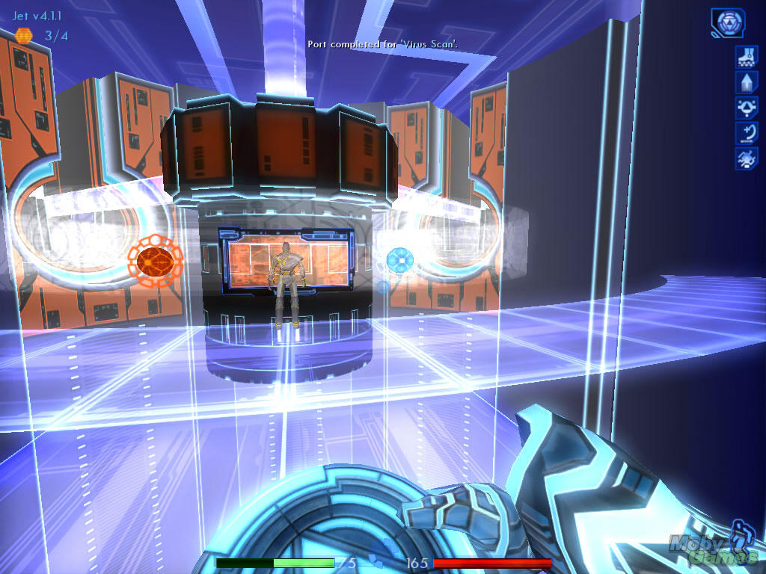
The setting of Tron 2.0 is a base for most virtual environments with its distinct glowing outlines and translucent paneling.

First, it allows for a visually striking aesthetic that doesn’t rely on a cartoony art style filled with caricatures and exaggerations. It makes it possible to use more realistic-looking art assets and prevents the game from coming across as too juvenile.

A VR-style look is easily attainable on the web-version of Unity, but an iPhone does not possess the same graphical capabilities. As a result, some of the effects would need to be removed or replaced, but the overall look could still be maintained across both platforms.

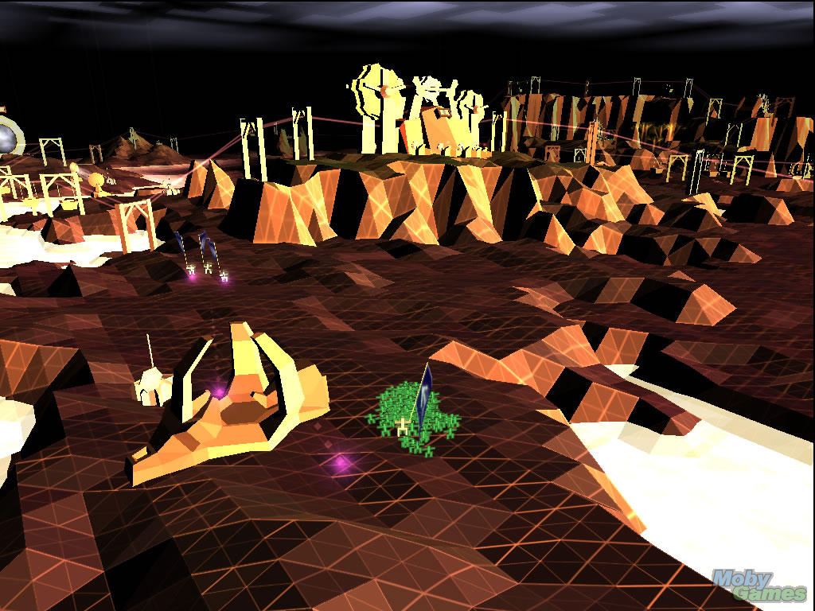
Darwinia’s geometric topography does a great job of outlining a 3D environment while creating a virtual look via a wire-frame of flat-shaded surfaces.

Secondly, a virtual setting lets the player make mistakes and learn from them – possibly the most powerful tool in teaching by using a video game. This is something that’s often avoided as the implications of accidents or negligence are quite negative. These will naturally be limited by the simulator itself, but the virtual setting separates them from real world consequences.

Finally, the VR approach serves as a training tool, and as such naturally parcels out the gameplay based on each career path associated with pipeline development. This is crucial as the audience is not immediately aware of every facet of pipeline planning, construction and maintenance.

Gameplay

The game takes place across multiple environments, each one played in a distinct series of phases. The training simulator guides the player through these phases, gradually explaining the tasks associated with each one.

To progress through a single level, each phase needs to be completed by performing micro-actions such as surveying, digging, and testing. These are accomplished by the player properly delegating his staff. Different workers are needed for different phases, and the challenge comes from using them as efficiently as possible.

Levels

Each level contains different construction challenges such as a permafrost tundra, mountains regions, dense historical sites, etc. The details of these will be based on the focus of the game, but they will provide an additional source of variety from level to level.

Different locations might also require different materials to be transported, in turn affecting the list of required tasks and workers. This allows VR Pipeline to utilize as many professions as deemed necessary by SAF and the sponsors.

Phases

Pipeline development is naturally divided into stages, and these are easily represented in the game. Each phase contains a list of specific tasks such as planning the Right-of-Way and digging a trench for the pipeline’s route.

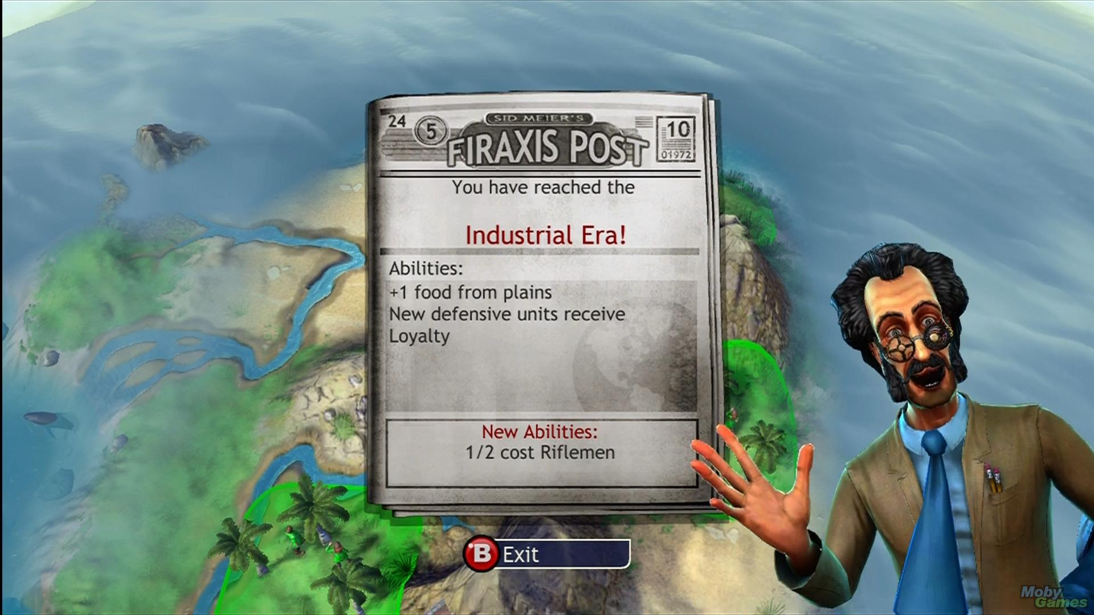
The famous Civilization series is also split into phases such as the stone age and the bronze age. Each phase changes the available gameplay by upgrading the technology and presenting new challenges and opportunities.

Since these objectives are associated with specific workers, it allows the game to group certain careers together. This is very important as it prevents the player from being overwhelmed with all possible careers and tasks at one time, e.g., PIG testing and maintenance is not part of the design phase, and therefore the player doesn’t have to worry about it until that phase is reached.

Individual phases also present clear goals to the player and create a sensation of always moving forward and achieving something positive. This works incredibly well at motivating the audience to keep playing – a new challenge is always just around the corner, and each one comes with its own rewards.

The suggested phases of each level in VR Pipeline are:

- Surveying
- Pre-Construction
- Construction
- Post-Construction

Units

Each “unit” in the game represents a distinct pipeline-related career. A list of available units is presented at the bottom of the screen for each phase. Clicking a unit’s icon automatically sends it out on a task.

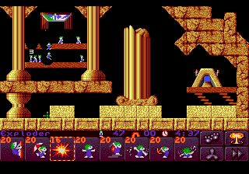
The classic Lemmings employed a list of available workers at the bottom of the screen. Clicking a worker activated his unique ability such as digging through soft soil or building a bridge.

A unit can only perform a single task, and once it is completed, the unit is removed from play. This forces the player to deploy units multiple times throughout each phase to complete it in full.

Controlling the units is the time/resource management aspect of the gameplay. Each unit can cost a certain amount of money, or only be deployed every so often, or simply be limited by a global level timer. The precise details of this management tactic will be derived from suggestions made by SAF and the sponsors, as well as play-testing sessions.

A suggested list of units and their abilities are as follows:

1). Surveying Phase
- Geomatics Engineer – reveals the topography and environmental makeup of the map.
- Civil Engineer – Visits sensitive locations such as parks and towns to obtain permits and indicate which areas a pipeline cannot be built on.
- Geotechnical Engineer – Examines the soil in the valid areas for a pipeline in order to prepare its route.

2). Pre-Construction Phase
- Line Producer – Creates a rough path of the pipeline’s possible route.
- Chainer – Places flags along the rough path to outline its details.
- Backhoe Operator – Digs the trenches for the pipeline once its path is defined.

3). Construction Phase
- Transporter – Delivers individual pipe pieces to the trenches.
- Welder – Connects the individual pipe pieces.
- Pipefitter – Aligns the pipe to its path in the trench.

4). Post-Construction Phase
- Heavy Operator – Covers up the pipeline with top soil.
- Pipeline Technician – Floods the pipeline with water and tests the initial pressure and flow.
- Pigging Specialist – Ensures proper working conditions of the pipeline by utilizing various types of PIGs.

Conclusion

A VR training simulator creates a striking look while gradually parceling out gameplay challenges to the player. It allows the experience to easily revolve around career paths and the desires of SAF and the sponsors, and affords a level of flexibility that is not available in a real-world setting.

Contact Information

Website URL: http://www.incubatorgames.com
General Inquiries E-Mail: info@incubatorgames.com

Radek Koncewicz, CEO and Creative Lead
radek@incubatorgames.com
+1.416.302.9127

David Churchill, CTO and Audio Lead
dave@incubatorgames.com
+1.647.628.6578

Tristan Campbell, COO and Programming Lead
tristan@incubatorgames.com
+1.416.830.4376

