

Project VRP GDD
April 29th, 2011
Table of Contents
Game Overview ２
1.0) Setting and Player Goals ３
2.0) Game Application Breakdown ７
3.1) Application Components ７
3.2) UML Diagram ８
3.0) Levels １０
4.1) The HUB １０
4.2) Level List １０
4.3) Level Components １１
4.3.1) Level Textures １１
4.3.2) Level Objects １２
4.4) Gameplay １３
4.4.1) Goals １３
4.4.2) Economy １３
4.4.3) Phases １５
4.4.4) Pipeline Format １５
4.4.5) Alerts １６
4.4.6) Powerups １６
5.0) Careers １８
5.1) Phase Workers １８
5.1.1) Phase 1 Units １９
5.1.2) Phase 2 Units ２０
5.1.3) Phase 3 Units ２０
6.0) Interface ２１
6.1) General UI ２１
6.2) HUB UI ２３
6.2.1) Status Bar ２３
6.2.2) Level Selection ２４
6.2.3) Science Info ２４
6.3) Level UI ２４
6.3.1) Status Bar ２４
6.3.2) Command Panel ２５
6.3.3) Map Iconography ２６
6.4) Tutorials ２６
7.0) Conclusions ２８
7.1) Focal Points ２８
7.2) Sample Playthrough ２８

Game Overview

Project VRP is an educational video game that encompasses the design, construction and maintenance of an industrial pipeline. It takes place in a virtual training simulator and focuses on various careers in the industry.

Using Unity3D as its main platform, Project VRP is targeted at Science Alberta’s Wonderville portal and the iPhone AppStore. The game uses SAF’s Kelvin mascot and its main audience group is 8-12 year olds.

The Project VRP is largely an asset-management game that educates the players about numerous scientific principles which serve as the bedrock of pipeline development.

Setting and Player Goals

The virtual reality setting represents a training simulator where numerous jobs associated with pipeline development are practiced. The setting gives a convenient excuse for the player to experiment with the game without any negative real-world associations.

From an aesthetic standpoint, the technological environment also creates a more mature experience that steps away from the cartoony look of SAF’s previous titles. The Kelvin mascot is still utilized for the sake of continuity, though, tying it together with the other games present on the Wonderville portal.

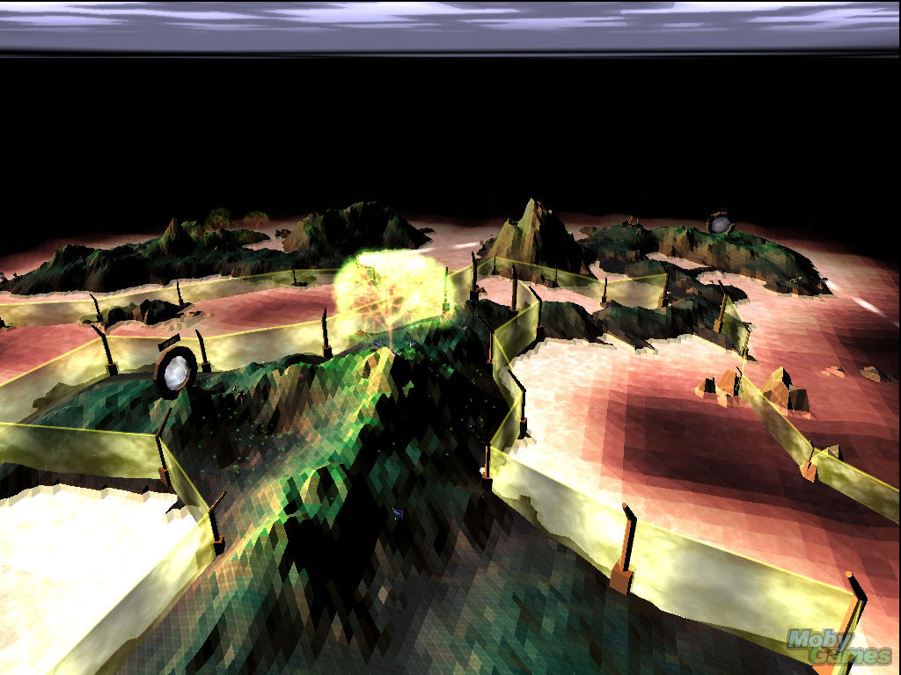An example of a virtual reality setting in Darwinia.

The role of the player in the game is that of an omnipresent manager, deploying various workers as needed. The workers perform their tasks automatically, letting the player observe and learn from them. This allows each task to be completed without the player’s previous knowledge of what exactly it entails, limiting the amount of instructions and micromanagement.

Throughout the game and each of its levels, the player is guided by the Kelvotron 5000, a digitized computer avatar. Kelvotron explains that the simulation is meant to take the player through various environments where pipelines must be built. At the end of the game, the player is awarded with a certificate/diploma that symbolizes his abilities and expertise.


A mischievous emoticon grin on a futuristic robot.

The Kelvotron is a construct that relies on two eyes and a mouth to form expressions akin to emoticons, e.g., ☺, ☹. These are instantly recognizable icons that can be used for evaluation purposes (smiley face for a good job, sad face for an inadequate one) while providing an emotional, human connection.

The avatar is also a framing device that’s used to summarize each level’s challenges, give an overview of all the possible pipeline workers/careers, present tutorials, and generally cheer on the player.

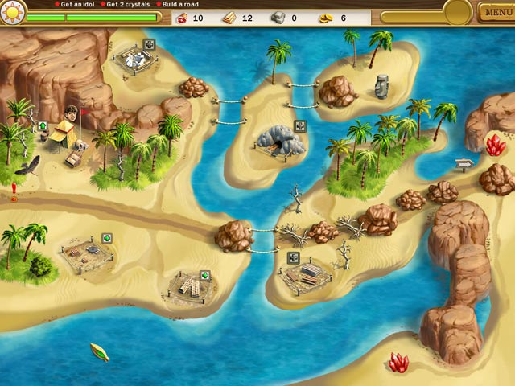
A path is outlined in Roads of Rome, with the player’s goal being clearing it out and executing on its construction.

The goal of each level is to construct a pipeline from scratch and connect it to various locations such as cities or pre-existing pipeline routes. This is done in three distinct phases: surveying & design, construction, and cleanup & testing. Each phase encompasses its own challenges and presents a unique group of workers applicable to the task at hand.

Base gameplay is facilitated via sending out workers into the map where they automatically explore the level, design the optimal pipeline path, construct it according to plan, and ensure that it runs smoothly. The challenge comes from gathering the resources necessary to deploy workers, sending them out in the proper order, and making sure that everything is done in as timely a fashion as possible.

This approach is a successful formula of various casual games that focus on single-level construction tasks. As a reference, the closest games that match this template are:

Roads of Rome - http://www.bigfishgames.com/download-games/9276/roads-of-rome/index.html

My Kingdom for the Princess - http://www.bigfishgames.com/download-games/5876/my-kingdom-for-the-princess/index.html

Game Application Breakdown

3.1) Application Components

This is a comprehensive list of all the distinct scenes and pop-up windows found throughout the game. The headings are as follows:

- Name – The name of the component.
- Type – Type of the component, scene for a distinct screen, and popup for any window that can appear on top of the scene. Note: it’s possible for multiple popups to be present at any one time, although only a single scene can be currently active.
- Description – A short overview of the component, what it represents, and how it fits into the game.
- Invokes – A list of scenes the current component can transition to, as well as a list of all its possible popup windows.
name | type | description | invokes
Loading | Scene | Splash screen with logos that serves as a transition between any scenes that require asset loading. | Any
Title | Scene | The main title screen. | - Options  - High Scores  - HUB
Options | Popup | Audio/tutorial settings. | None
High Scores | Scene | A list of all the high-scores of the game. | - Title
HUB | Scene | A map of all of the game’s levels. | - Level  - Title  - Tutorial  - Career List  - End Game
HUB Menu | Popup | Audio/tutorial settings, as well as exit to Title option. | - Title
Level | Scene | An in-game level. | - Level Menu  - Tutorial  - New Phase  - Career List  - End Level
Level Menu | Popup | Audio/tutorial settings, as well as level resume/restart and HUB exit. | - Level  - HUB
Tutorial | Popup | A visual and text aid for learning the game. | None
New Phase | Popup | A reward pop-up that ends the previous phase and introduces a new one. | - Tutorial (optional)
Career List | Popup | A list of images and text descriptions giving an overview of every unit in the game. | None
End Level | Popup | An end-level summary. | - Level  - HUB
End Game | Scene | A celebratory screen informing the player that he has passed the game. | - High Scores Entry
High Scores Entry | Popup | A window that let’s the player input a name for his high-score. | - Title

3.2) UML Diagram

The following diagram shows the scene-flow of the entire application. The name in the tab indicates the scene, while the list inside details all the possible popups.
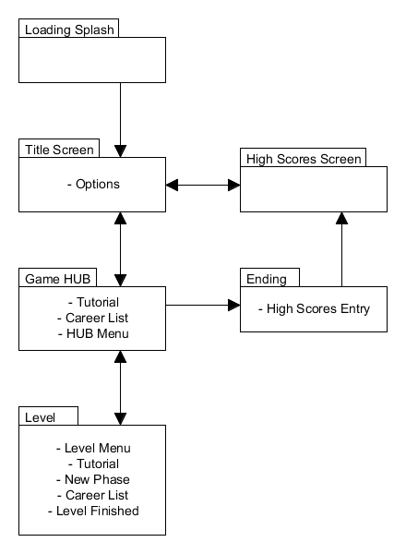

Levels

4.1) The HUB

The HUB area is an abstract overworld map composed of multiple cells, with each cell linking to an individual level.

The levels are played in a semi-linear order which is as follows:

- Level 1 is a mandatory tutorial level that mush always be completed first.
- Levels 2-5 can be played in any order after level 1.
- Level 6 can only be played once all of the first 5 levels have been completed.

Clicking on a level-cell smoothly zooms in the camera and starts that level, foregoing any extra transitions. A similar approach is taken when a level is finished; the camera zooms out and presents the player with the HUB map.

The virtual reality setting also affords us the possibility to use drastically different environments side by side, e.g., a tundra next to a desert. This affords plenty of variety in the setting and construction challenges.

4.2) Level List

The following is a quick overview of each level and its unique attributes.

ID | Description | Challenges
1 | Flat plains. | Learn the interface of the game and complete basic tasks in a relatively empty environment.
2 | Forested region. | Avoid national parks and other wildlife, ensure moisture does not corrode the pipes.
3 | Hot desert. | Treat pipes for high temperatures, possibly build above ground due to hard soil.
4 | Mountainous region. | Properly install compression and safety stations to deal with the elevation changes.
5 | Icy tundra. | Build above the ice, use special rollers for pipe base due to temperature changes.
6 | Flat plains. | This time the plains are densely populated and the pipeline needs to be linked to an existing one.

4.3) Level Components

4.3.1) Level Textures

All of the topography in the virtual levels is painted over with flat, slightly pixilated colours in order to achieve a computer-generated look. This palette is based off of the different environment types, many of which are blended together in each level.

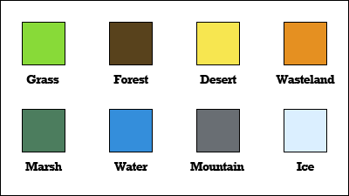
An example of the colours used to paint each level’s environment.

4.3.2) Level Objects

In addition to the base level topology, each map is also populated by numerous objects that are decorative or serve gameplay purposes. Whether objects are 2D or 3D will depend on their use and technical implementation.

The following is a full list of level objects.

name | Description
Injection Station | Starting point of the level and its pipeline. All units emerge from this location when they first appear on the map.
Steel Pipe Piece | A single piece of the default pipe.
Red Pipe Piece | Default pipe treated for hot temperatures.
Blue Pipe Piece | Default pipe treated for cold temperatures.
Black Pipe Piece | Default pipe treated for erosion.
Green Pipe Piece | Default pipe treated for corrosion.
Cross Piece | The meeting point of two welded/bent pipe pieces.
Flag | Used to dot a path for the pipeline.
Top Soil | Dug-out earth temporarily placed to the sides of the pipeline path.
Pump Station | Built periodically alongside the pipeline, these stations ensure that contents are always under enough pressure for proper transportation. Extra pump stations are also built along the base of an elevation in order to ensure that the contents make it safely “uphill”.
Regulator Station | Built periodically alongside the pipeline, these stations ensure that sections of the pipeline can be shut down an isolated in case of an emergency. Extra regulator stations are also built at the base of elevations in order to ensure that the contents make it safely “downhill”.
Pipeline Platform | These platform bases are constructed to hold up the pipeline when it’s not feasible to place it underground.
Town | An urban settlement, end-point of some pipelines.
Farm | A rural settlement, needs to be avoided.
Archeological Dig | Unique site that needs to be avoided.
Natural Mine | Unique site that needs to be avoided.
Road | Tileable highways that can’t be crossed.
Track | Tileable train paths that can’t be crossed.
Tree | Decorative prop to be avoided.
Rubble | Decorative prop to be avoided.

4.4) Gameplay

4.4.1) Goals

The goal of each level is to create an entire pipeline section before a generous time limit runs out. The maximum duration of this limit is identical from level to level, but a bonus is awarded for completing all the work under a specific amount of time. This secondary goal is different in each stage, but any time that’s left over when a level is completed counts as a bonus.

Building a pipeline and passing a level involves properly managing one’s resources and using all the available workers in a timely fashion. Each one of these elements is described in the following sections.

4.4.2) Economy

The base resource metric in the game is the “credit”. It’s something of a universally identifiable currency that also fits with the virtual reality theme of the game. Furthermore, the credit’s abstract nature lets us play around with the costs of workers/tasks without needing to stick to real-world equivalents.

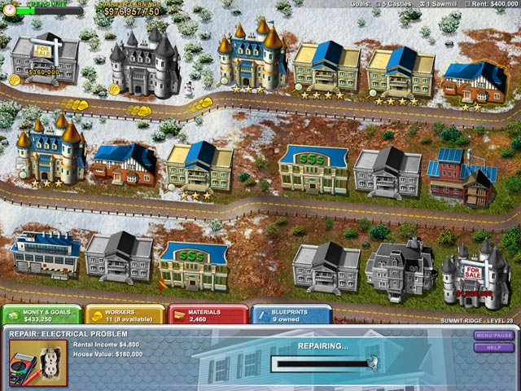
The casual game Built-a-Lot has a very strong focus on finances and remains one of the most successful build-management games of all time.

With credits as the base resource, each player action costs a certain amount of money, but each successful action also brings in more money once it is completed. For example, sending out a backhoe digger to dig a trench can cost 2,000 credits, but when he’s finished, the player receives 3,000 credits.

The challenge comes from sending out as many workers as needed, but not wasting any money on workers with no valid tasks, e.g., sending out a Line Producer to create the pipeline’s path before a Geotechnical Engineer has examined the soil will not place any flags but still waste the money involved in the task.
Although it is possible to run out of money, it is a resource that’s constantly replenished via completed tasks, finished phases, acknowledged alerts, and various level-timer intervals.

Additional “permits” might be required to perform some of the tasks, and will be collected by a specialized worker.

4.4.3) Phases

Each level takes place in three linear phases described below:

Surveying & Design – Scoping out the map, figuring out which areas of it are valid for construction, and designing a pipeline route that’s as short as possible without disturbing local settlements and sensitive locales such as parks or heritage sites.

Construction – Digging a trench, delivering the pipe pieces, positioning the pipes, and welding them together. Any other extra work such as construction of pump and regulator stations is also done at this time.

Testing & Cleanup – Coating of pipes with environment-resistant substances, filling up the trench with top-soil, and using pigs and other devices to test the integrity of the constructed pipeline.

4.4.4) Pipeline Format

The pipeline itself can be constructed either above grade (on land) or below grade (underneath soil). It can also switch between these approaches within a single location, especially when crossing obstacles such as roads and rivers.

The pipeline’s colour changes as well to reflect its attributes. Green is the default corrosion-protected coating, blue is used for low temperatures, red for high temperatures, and black for high pressure/resistant sections.

4.4.5) Alerts

Alerts are randomly generated events that take place in the level and require the player’s attention. All alerts show up as an icon on the map that needs to be clicked in order to address the issue at hand.

Alerts serve to give the player another element to manage while facilitating additional jobs that are not represented in the rest of the gameplay. If an alert is not dealt with, it will eventually disappear and the player will be penalized a small amount of money.

Below is a list of all the possible alerts in the game.

- Bad Weather – Construction needs to be temporarily halted/covered in order to protect the workers and not waste any materials due to rain, snow or dust storms.
- Noise Pollution – Construction needs to be managed in order to decrease the amount of noise it emanates.
- Repairs – Machinery at the site needs a tune up to proceed efficiently.
- Extra Components – Pre-made bent pipes and other construction material needs to be occasionally delivered to the site.
- Rare Species – A rare species of flora and/or fauna is discovered and needs to be handled with care.

4.4.6) Powerups

The only powerup in the game is a speed boost that temporarily increases the rate at which the workers move on the map and perform their tasks. In order to activate this powerup, a special segmented bar needs to fill up be performing tasks and addressing alerts.

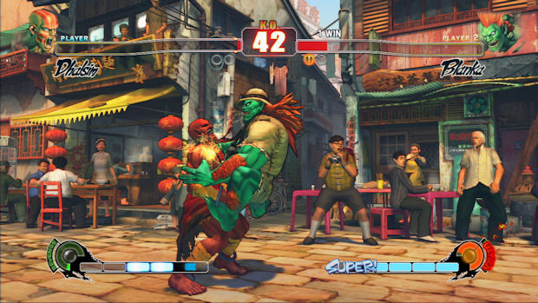
Two segmented “super bars” appear in the lower portion of the screen in the popular fighting game Street Fighter IV.

5.0) Careers

5.1) Phase Workers

Each phase represents a group of workers unique to the tasks at hand. The specific workers in each phase also change depending on the environmental challenges in the level.

Hotspots on the map appear and disappear as tasks are completed. Each hotspot shows a number/icon of the worker that it requires, and is either filled in or grayed out based on whether a worker can currently access the hotspot.

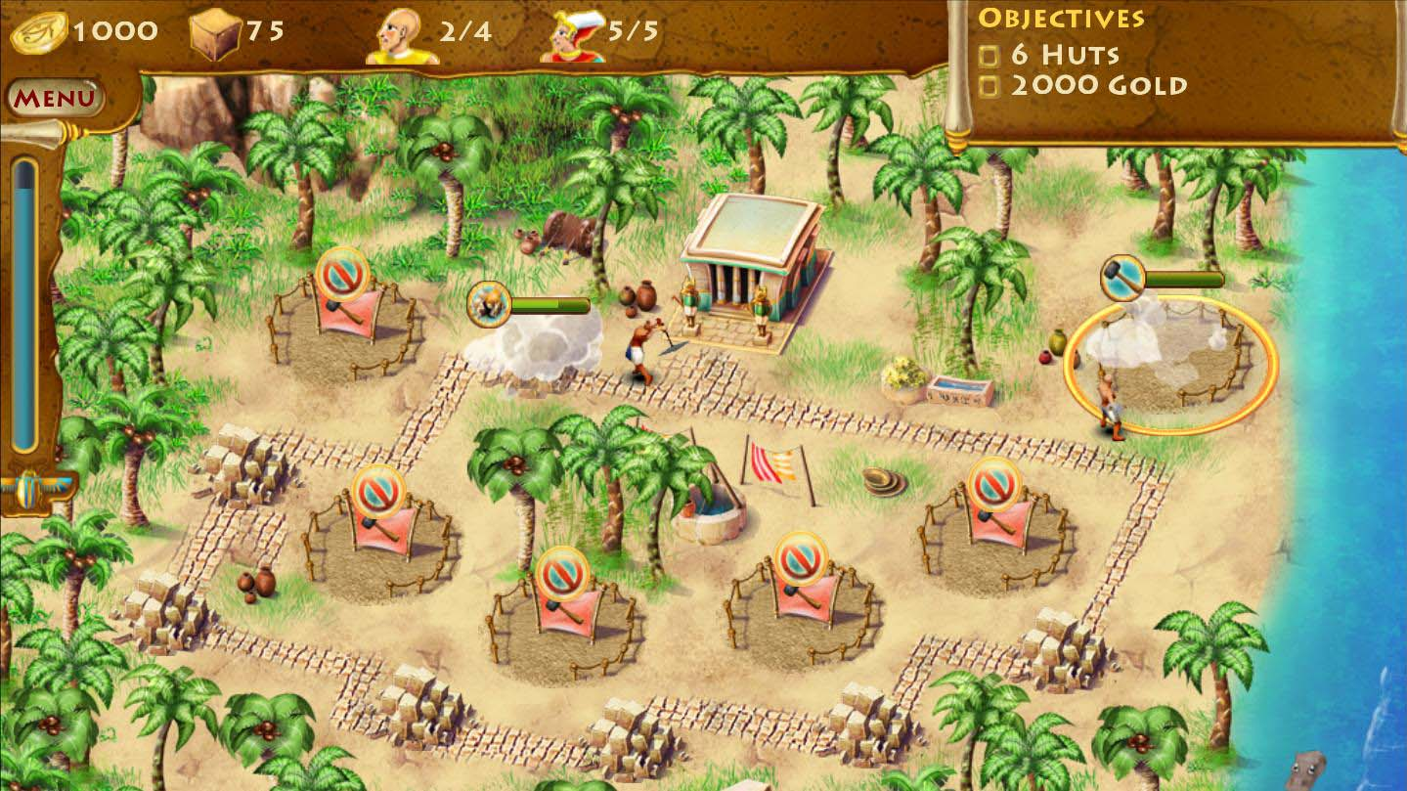
Two workers simultaneously performing two different tasks in Pyramid Rising: one is 2/3 done clearing the road of debris, while another is just starting construction on a building.

Once a worker is clicked in the user interface, it automatically seeks the closest hotspot it can access and starts performing a task. This process takes time, and a completion bar pops-up over the hotspot. Once it finishes filling up, the hotspot disappears and new hotspots can pop up on the map.

Following the successful completion of a task, the worker returns to the starting base of operations and can be deployed to other hotspots. If a deployed worker cannot find a valid hotspot, it also returns to the base.

Each phase has a maximum of five available worker types, but the amount of workers for each type changes from level to level. In the first stage, each type only has one or two workers available, but at the end of the game it’s not uncommon to have three workers for each position.

In addition, each type of a worker gains experience throughout the game by performing tasks (this is indicated as a % number in the new phase and career list popups). When the worker has gained 100% experience, that worker now counts as having been “mastered”, unlocking new info in the career list popup and performing his tasks with a permanent 33% speed boost.

Finally, a “Civil Agent” is present throughout all three phases and is responsible for acquiring any necessary permits.

Below is a list of workers in each phase. The order column represents the rough order in which workers are sent out into the field. An NA status means that the worker only appears on some maps that contain special environmental challenges.

5.1.1) Phase 1 Units

ORDER | name | Task
1 | Geomatics Technician | Reveals the topography and makeup of the level.
2 | Chainer | Investigates the seismic lines and plots a rough path for the pipeline.
3 | Design Engineer | Creates a draft of the pipeline to be constructed based on the desired path.
NA | Geotechnical Engineer | Examines soil samples and slopes and difficult passages to properly plan out the pipeline’s route.
NA | Utility Locator | Locates underground utility lines and existing pipelines.

5.1.2) Phase 2 Units

ORDER | name | Task
1 | Backhoe Operator | Digs a trench for the pipeline.
2 | Trucker | Delivers and dumps pipeline pieces.
3 | Welder | Stitches the pipelines together.
NA | Bulldozer | Removes obstructions on the pipeline path.
NA | Builder | Constructs pressure/valve stations.
NA | Demolitions Expert | Blasts dunes/mountains to carve out a path for pipeline.

5.1.3) Phase 3 Units

ORDER | name | Task
1 | Corrosion Controller | Checks the resistance of the pipeline.
2 | Stress Engineer | Checks pipeline for stress points, floods with water for testing.
3 | Front End Loader | Covers up the pipeline with top soil.
4 | Pigging Specialist | Uses various pigs to test the pipeline and clean it.
NA | Remediation Manager | Disposes of waste and byproducts of construction.
NA | Environmental Engineer | Makes sure the environment is not harmed during cleanup process.

6.0) Interface

6.1) General UI

The largely aesthetic user interface components of Project VRP will follow the pattern set out by Kelvin’s Space Ranch and The CO2 Connection. These previous Wonderville games relied on a minimalistic design for each screen, large, decorative buttons for controls, and pop-up windows for options and transitional messages.

Below are some examples.

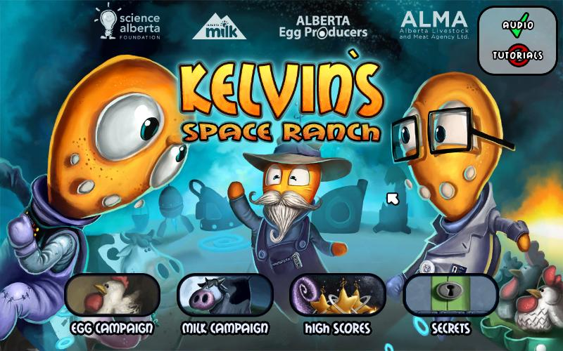
The Title Screen of Kelvin’s Space Ranch

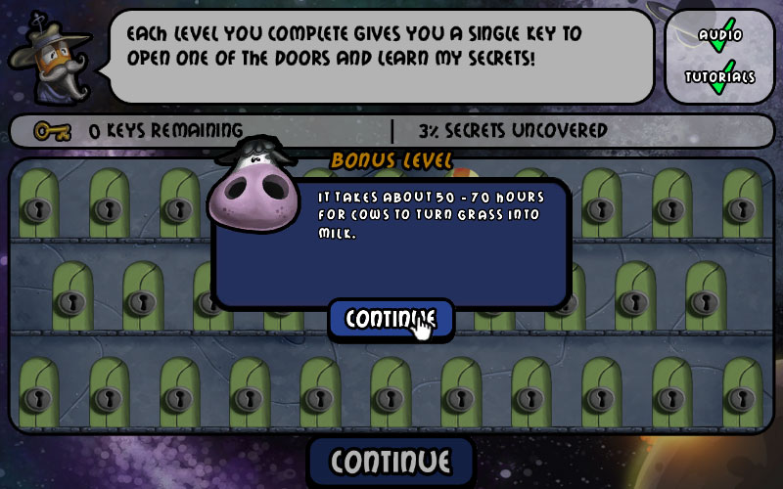
An example of a simple message pop-up.


The CO2 Connection’s High Scores screen.

6.2) HUB UI

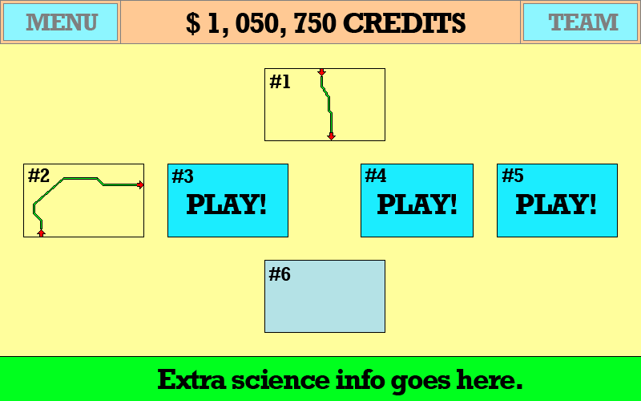

6.2.1) Status Bar

The horizontal Status Bar is located at the top of the screen and is tinted with a pinkish background.

The Status Bar consists of three main components: the menu button, which pops up a window with some basic game and navigational options; the score display, which shows the amount of money earned from all levels combined; and a team button, which pops up a window listing every type of worker in the game.

The team button also pulsates or is appended with a “new!” label whenever any new data on the workers is unlocked. This happens at the beginning of the game when the player hasn’t viewed any worker info, as new workers are introduced via each phase/level, and as workers are mastered.

6.2.2) Level Selection

The yellow-tinted area is the level selection HUB that shows all of the game’s stages. Completed stages (#1) are unveiled and show the constructed pipeline; next-up stages (#2) are highlighted with the button colour and display the word “PLAY!”; and future levels (#3-#9) are grayed out.

6.2.3) Science Info

Extra scientific info is presented in the green bar at the bottom of the screen. These little tid-bits change randomly and represent data that is not touched upon in the levels themselves.

6.3) Level UI

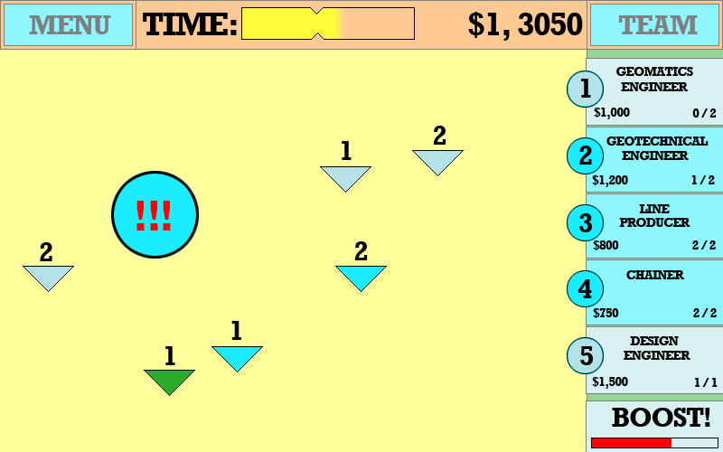

6.3.1) Status Bar

The Status Bar is almost identical to the HUB Status Bar, with one difference: instead of showing an all-time money counter, the bar displays a level-timer and the current amount of money.

The level-timer is represented via a notched bar and its fill gradually depletes as the game is played. The notch represents the bonus-goal and if the level is completed before the yellow fill reaches the notch, the player receives an extra reward. If the fill reaches the notch, it turns into a red colour and no bonus is granted. If the fill is completely depleted, then player fails to advance to the next level and must replay the current one.

It’s worth noting that the level-timer is not represented via a numerical countdown as such metrics tend to evoke a feeling of tension.

6.3.2) Command Panel

The vertical Command Panel is green tinted area on the right side of the screen (mostly obscured by bluish and grayish buttons).

The first five buttons represent the workers for the current phase. Each button contains the name of the worker type (later to be replaced by visual icons), the amount of money it costs to send a worker out into the field, and the amount of workers currently available. The circular tab with a number to the left of the button indicates which hotspot the worker can address.

The bluish-coloured buttons can be pressed at any time to send out individual workers, while the grayed out ones are currently unavailable. The buttons change colour/status from valid (blue) to invalid (gray) as the game is played. Buttons are blue by default and only change to gray if there are no more workers left to send out or the player doesn’t have enough money to pay for the worker.

Finally, the boost button and bar are displayed in the lower right. When the boost bar fills all the way up (by performing tasks), the button changes to a blue colour and can be pressed to temporarily speed up all workers.

6.3.3) Map Iconography

The yellow-tinted area is the map of the current level.

The triangular arrows pointing down are the hotspots, and the numbers above them show which workers need to address them. The hotspots also contained a colour-coded fill: green for a worker is already completing the hotspot’s task, blue for a worker is needed and the hotspot is accessible, and gray for a hotspot that cannot be reached just yet.

The large, blue circle with three red exclamation points is an alert pop-up. In the final version, the circle contains an icon representing the type of alert, and it will fill up with a red colour to indicate that it’s a time-sensitive event.

The player needs to manually click on all alerts as they pop-up in order to take care of them in a timely manner.

6.4) Tutorials

All tutorials in the game are presented via a talking-head of Kelvotron, along with a bit of text and optional arrows pointing to the game-components the text is addressing.

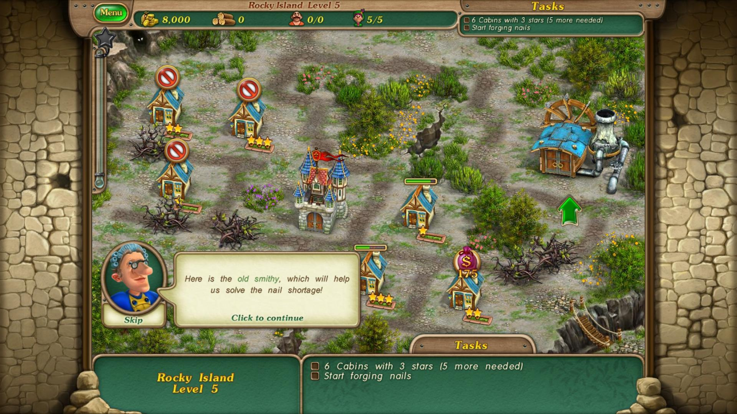
An example of a talking-head tutorial in Royal Envoy.

Tutorials can appear on either the HUB scene or in a level, and clicking anywhere on the screen while a tutorial is present will dismiss it.

7.0) Conclusions

7.1) Focal Points

The following is a list of high-level concepts and key features of the game as suggested by the developer (Incubator Games), the Science Alberta Foundation, and the sponsors.

Any changes to the Project VRP should be first weighed against this list in order to spot any possible conflicts.

- Virtual Reality affords the flexibility that a real-world setting cannot.
- Futuristic aesthetics and digitized speech provide high-end production values.
- A strong focus on careers in pipeline development presented with various iconic Kelvin characters.
- No references to real world locations or individuals.
- Scientific facts presented via construction challenges and in-depth career descriptions.
- Automated movement and construction that limits micromanagement and avoids issues with the small screen of an iPhone.
- Avoidance of tasks that require the player to have prior knowledge of pipeline design, replaced with a focus on management and gradual unveiling of the most optimal solutions.

7.2) Sample Playthrough

With the base gameplay set, here is an example of a playthrough of the first phase from the starting level.

- The player clicks twice on the Geomatic Engineer to send out two units to explore the blank map.
- The two Geomatic Engineers rush to two hotspots, and the first one finishes exploring it. This grants the player some money and reveals two more hotspots.
- While the second Geomatic Engineer is still exploring his area, the player clicks on two Geotechnical Engineers and sends them out.
- The second Geomatic Engineer finishes exploring his part of the map and reveals another hotspot. However, the player doesn’t have enough money to send out any more units.
- The Two Geotechnical Engineers finish examining the soil and reveal one more hotspot. This gives the player enough money to send out another Geomatic and Geotechnical Engineer.
- A city pops up with an alert, and the player clicks on it to acquire a permit and gets some extra money in the process.
- When the two Engineers finish their tasks, three more hotspots appear. However, the player only has enough money to send out two units.
- When the workers in the field finish their tasks, the map is fully revealed alongside and two more hotspots, and the player gets a money bonus.
- The player now has enough money to send out three Geotechnical Engineers to examine the rest of the soil.
- When the three Engineers are finished, a series of hotspots pop up and the player sends out Line Producers to create a path for the pipeline.
- While the Line Producers are at work, a bad weather alerts pops up. The player clicks on it and gets a money bonus.
- As the Line Producers finish their work, the player clicks on the starting position hotspot to begin drafting a design for the pipeline. At the same time, he uses the rest of his money to send out Chainers to place flags along the Right-of-Way.
- When the design is finished and all flags have been placed, the phase is deemed complete. The player receives a time bonus, and new workers replace the old ones for the next phase.

