

The CO2 Connection
(Working Title)

DRAFT v2010012801
Working Document
1). Premise

The game revolves around capturing, transporting and sequestering of CO2 throughout the province of Alberta, effectively reducing its CO2 emissions. Scientific information on the capture, purification, transportation, usage and storage of CO2 is provided via gameplay to help explain all the facets of the process. The overall experience gives the player a deep understanding of CO2's importance in todays environment.

2). Gameplay Overview
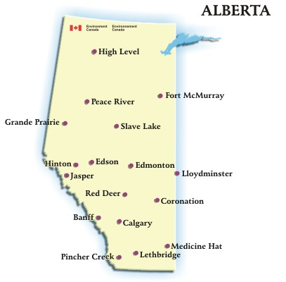
A map of Alberta with some its key locations.

The core of CO2 Alberta is similar to common traffic simulators such as Sid Meier's Railroads, except with a simplified rule set akin to the hit online game Oasis. The goal of the game is to build a network of pipelines capable of transporting liquid CO2 to and from various locations in Alberta. The player starts the campaign at Enhance Energy's current base, and spreads out to cover many parts of the province.

Each new section of Alberta is its own level, and the player has some choice as to the order in which he plays through them. The goal of the game is to build a pipeline infrastructure in the available stages and attain the highest “Score/Minimal Footprint” possible.

  - Overworld Hub
The “overworld hub” is a map of Alberta and the player's entry point to the game. At the beginning of the campaign, only the home base of Enhance Energy is lit up and visible, with all other sections grayed out. The player can choose any tiles adjacent to the lit up areas to play one of the levels. Once the level is beaten, its location becomes lit up on the hub map and further levels can be accessed.

The hub is also responsible for launching individual minigames that take place between the levels. These minigames deal with the capture of CO2, gas-to-liquid compression of CO2 for transportation, seismic scanning of potential reservoirs, and actual usage at oil reservoirs for the purpose of sequestering and extracting extra oil.

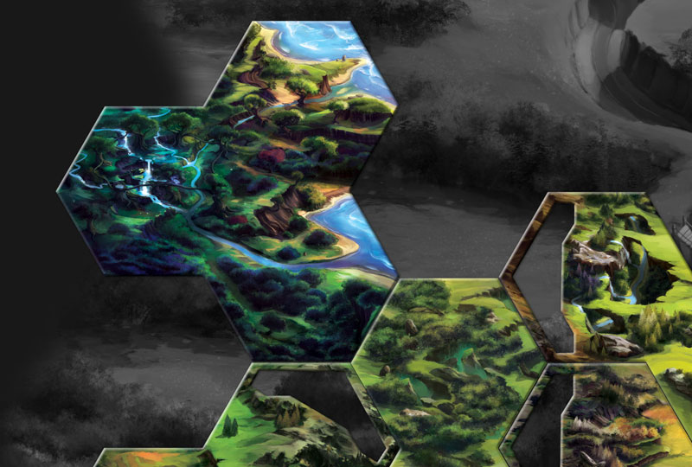
An example of an Overworld Hub from Runewars. As new hexagons are uncovered, more of the actual map is revealed.

  - Level Maps
Each level representing a sub-section of Alberta is roughly 10x8, for a total of 80 individual tiles. Levels also have three basic units of measurement: Turns, which start at 100 and count down; Resources, which start at 0 and can go either up or down; and the Score, which starts at 0 and (usually) goes up.

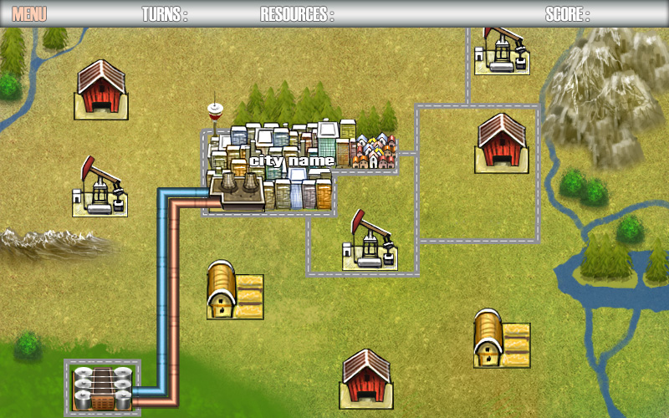
In-Game Level mockup showing a basic layout.

At the beginning of the level, most of the tiles are covered by a translucent fog-of-war overlay through which the player can see the general structure of the map, but not the details; roads and major cities will be visible, but not terrain types. Clicking on an obscured tile will represent a geological survey, costing 1 turn while unveiling what's underneath it. If the revealed tile is suitable for building a pipeline, the Resource counter will go up by 1.

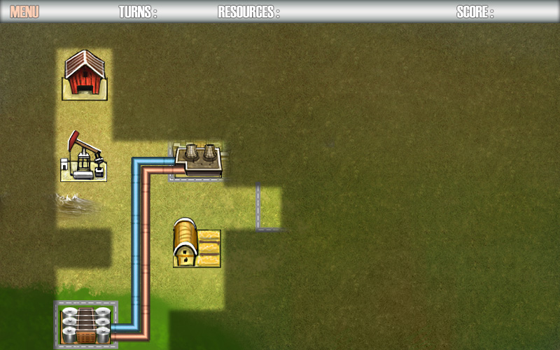
In-Game Level mockup showing the fog-of-war mechanic and how it could potentially obscure portions of the map.

The mechanic of raising the Resource counter will serve as a constant reward for revealing virtually any part of the map, and will encourage the player to explore as much of it as possible. The removal of fog-of-war will also reveal more detailed information about the land, and maybe the occasional small farm or abandoned oil reservoir providing a sense of exploration. By default, though, major landmarks of any area will be visible so that the player can plan a rough layout for his pipe network.

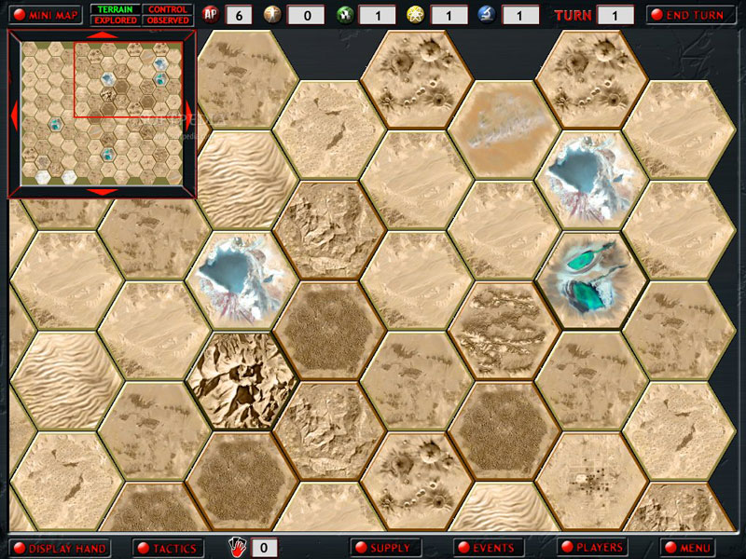
Examples of different desert terrain types in Armageddon Empires.

As the fog-of-war is recedes, the player will lay down pipes and use them to connect various objects on the map to increase his Score. Due to the nature of turns, the player will never be able explore every tile of the map, but will get to unveil most of it during his playthrough. This will leave a bit of wonder as to what else is hidden the levels, and will encourage him to properly plan ahead the pipe network.

Each map will contain at least one major object such an city or an oil reservoir. The cities will be represented by their best-known landmarks such as the Calgary Tower or the Edmonton Mall, allowing the kids who play it to identify with the locations. Connecting these spots (or in the case of cities, their factories) to the pipe network will result in a special achievement pop-up and earn a large Score bonus. Using up all the turns without reaching a minimum Score will fail the level, forcing the player to restart it or lose the points he gained.

Each level will take 3-4 minutes to complete, including building the pipe network.

  - Pipe Network
Each level will begin with a few fully visible tiles and a pipe station. The player will extend all his pipelines from this station in order to complete the level. Building a pipeline is done by clicking on a fully visible tile that's suitable for a pipeline that also happens to be next to an existing pipe. When this is done, the Turns and Resources counters will go down by one, and the Score/Minimal Footprint up by a small amount. Pipes are automatically merged with adjacent pipes, removing the need to drag and drop different pipe pieces.

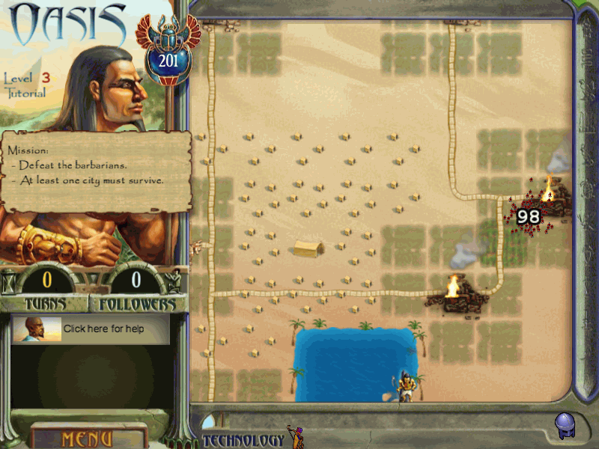
Building pipelines in CO2 Alberta is reminiscent to building roads in Oasis.

If two pipes are connected to a single pipeline, a split occurs. Once a pipeline is connected to a place that either produces or requires CO2, a large Eco-Bonus is doled out and animated arrows begin to show the flow inside the pipes. Each pipe contains two lanes, one for incoming and one for outgoing. Places that produce CO2 send the liquified gas through the pipe in one lane, while places that use it (oil reservoirs) receive it through the other lane.

Clicking on an exiting “pipe” tile removes that pipe, costing the player a turn and breaking any existing connections (and with them the bonuses earned by connecting individual map locations). This is to prevent the player from having to restart the level upon an accidental pipe-build event, but also to remind him not to frivolously lay down pipelines.

With this approach, the whole interface only requires single button clicks on areas of interest, reducing complexity and the barrier of entry.

  - Object Types
Each level is filled with a plethora of terrain types and locations. These include:

- Empty sand and grass fields perfect for laying down pipelines.
- Bedrock, roads and mountainous areas where laying down pipes might be impossible or cost an extra turn.
- Human establishments that are off-limits and must be avoided.
- National parks and reserves that need to be avoided by multiple tile spaces in order to abide by government regulations.
- Active and abandoned oil reservoirs that require CO2 for more efficient oil extraction.
- Industrial parks and factories that produce lots of CO2.
- Lakes and rivers that cannot support pipelines.

Other terrain and location types can be implemented as needed.

In addition, it's worth noting that uncovering the fog-of-war has a minesweeper-like element to it that provides depth to the gameplay by hinting at which areas should be uncovered. For example, clicking on an obscured tile that reveals a beach will let the player know that adjacent tiles hide a lake, and therefore he should not waste his turns uncovering them. Conversely, half-obscured dirt roads might lead him to oil reservoirs no longer in use that can grant a large Score bonus.

  - Minigames
Between each level, a single 2D minigame will take place. The minigame will reflect a major event that took place in the previous level, or is about to take place in the next level. These events will include compressing gas for the ever-extending pipe-network, seismic surveys of potential storage sites, capturing and purifying CO2 from producers currently connected to the network, and storing that actual CO2 gas while extracting oil from existing reservoirs.

Each minigame will have to be played at least once, after which the player will have a choice of which one to compete in after any given level. Successfully finishing a minigame will upgrade it, giving the player a greater Score bonus whenever its activity is referenced in a map. For example, completing the CO2 storage/EOR minigame will give the player more points whenever he connects an oil reservoir to the pipe network.

The upgrade itself will not influence the mechanics of the game as a whole, but simply provide a potentially large Score bonus. As a rough guideline, the player will be able to upgrade each minigame a maximum of 3 times.

This approach will let us space out the minigames, adding variety to the game's pacing without overwhelming the player with new information and instructions. The variety of the minigames will also allow us to showcase any scientific or technical activities without bogging down the map exploration part of the game.

The minigames are planned as follows, although suggestions and requests are welcome:

CO2 Extraction & Purification
This minigame will closely follow a simplified version of the gasification process. It will of three main parts: the gasifier, the purifier, and the CO2 repository.

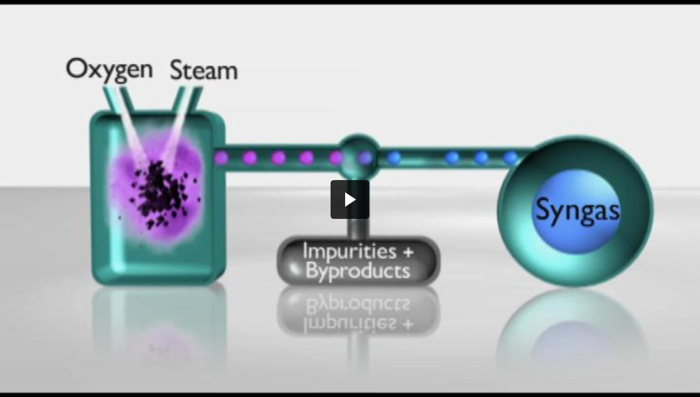
Simplified gasification diagram – in our version of the process, we will focus on producing CO2 instead of Syngas.

A slurry of broken down solids, liquids and gasses will enter the gasifier from the bottom, while a stream of steam/oxygen will enter from its left side. As the pressurized gases hit the slurry, they will break it apart on a molecular level and propel it through a tube attached to the gasifier. The substance will then travel through a purification center, and will finally be stored in the CO2 repository.

The player's job is to keep a constant flow of steam/oxygen and slurry coming into the gasifier, while rejecting the end results that are impure. Two circular meters are placed in the gasifier, one by the steam/oxygen stream, and one by the slurry stream. The meters are perpetually shrinking, and as they do, the two inputs associated with them slow down. The player must occasionally click on these meters to refill them and guarantee a steady stream of resources.

As the molecules exit the gasifier – small, green ones that move quickly and represent pure CO2, and big, red ones that move slowly and represent the impurities and byproducts – the player must weed out the impure components by clicking on them, at which point they exit to the impurities/byproducts repository.

The game ends after about 1 minute, and the player's score is measured by how much CO2 he has collected while maintaining a 99% purity rating – both metrics are measured within the minigame by counters shown in the CO2 repository.

Gas-To-Liquid Compression
A grid-based minigame that focuses on the compression of CO2 into a liquid state so that it can be transported through the pipe network.

The game's grid is about 8x5, with the top and bottom parts serving as entry and exit points to the machine. Inside the machine, various pipe pieces occupy each square. Each pipe-piece can be rotated by clicking on it, and can connect to between 1-4 of its adjacent sides (based on its visual extensions). The exit points of the machine all combine into a single pipe that leads to a “bottleneck” point where a compressor condenses the numerous streams of gas molecules into a single stream of liquid CO2.

The thick pipes that carry the gas molecules will help to visually indicate that a large quantity of gas is funneled into a single point where the compression takes place, after which only one small pipe will be necessary to transport the liquid CO2.
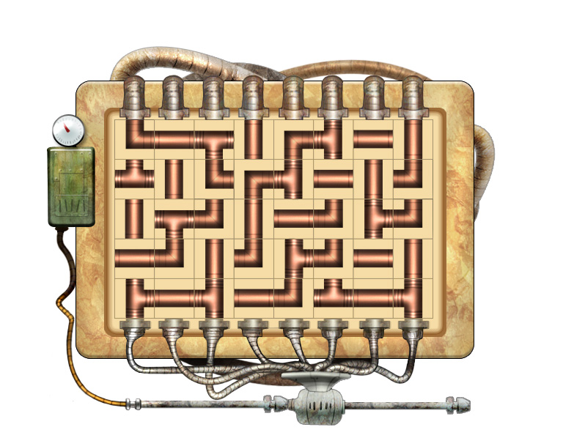
A mockup of the Gas-to-Liquid compression minigame. Each successful connection leads to a compressor and increases the pressure

When the minigame starts, all of the squares on the grid contain random pipe pieces, and a random number of entry and exit points are opened. The player's goal is to rotate the pipe pieces and form a connection between all the entry and exit points. With each connection, the pressure-valve on the left side will increase, signifying that the pressurizer is getting closer to its desired 1000lbs measurement. The “round” end when all the connections are made, and the entry/exit points as well as all the pipe pieces are randomized to create a new “board.”

In total, there 3 rounds will take place before the game is completed, and extra points will be awarded to the player based on his time of completion. Each game will take about 2 minutes to complete.

Seismic Surveying
In this minigame, the player sweeps over blurred shots of a cross-section of an oil reservoir. His reticule represents a precision scanner that needs to analyze certain parts of the soil, bedrock, remaining water/oil levels, and amount of free space for the liquid CO2.

Whenever the player presses and holds the left mouse button, he enters a “focused” mode where the speed at which the reticule moves is greatly reduced but extra details are shown inside the reticule such as the size and shape of the cavity and oil/water levels. Letting go of the button immediately brings the game back to the blurred mode and the cursor speed goes back to normal.
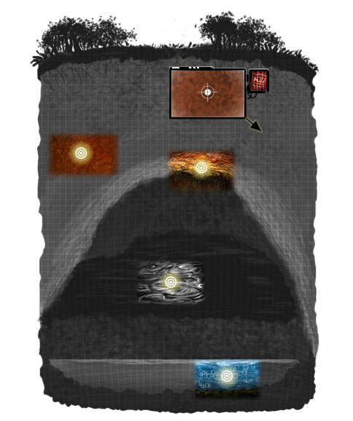
Seismic scanning mockup showing 4 revealed hotspots (without borders), and the player's cursor (the bordered window) pointing to the last remaining hotspot.

While in the focused mode, the player must guide the reticule and its crosshair over a number of hotspots with glowing centers scattered around the image. In this mode, an extra arrow indicator will point the player to the closest hotspot, and a Geiger-like counter will visually and aurally help to guide him with “hot” and “cold” feedback.

The hotspots themselves will be randomly scattered around the image, and passing the minigame will require finding all of them as quickly as possible. Once all the hotspots are discovered, the entire non-blurry image will appear serving as a reward for the player.

The minigame will last roughly 1.5 minutes.

CO2 Sequestering and EOR
CO2 sequestering and Enhanced Oil Recovery are part of the same process that centers on pumping liquid CO2 into previously used oil reservoirs. The minigame will show a large scale image of the facility and the reservoir below it, with two pipelines leading in and out of it. The first pipeline will be used to pump liquid CO2 into the reservoir, filling the porous rock while dislodging the oil and increasing the cavity's internal pressure in order to pump the oil up through the second pipe.

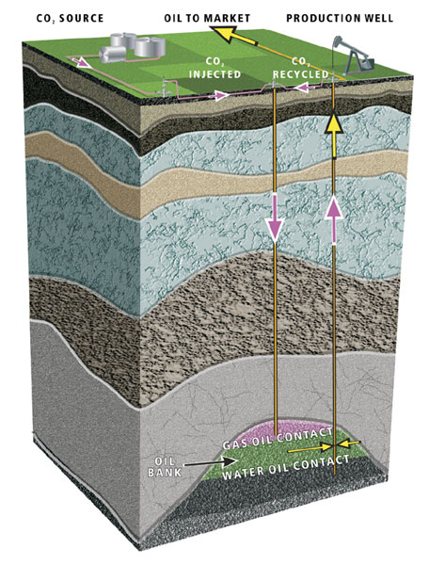
A cross-section of an oil reservoir and the production facility that uses vertical flooding.

The mechanic for this process will come in 3-4 rounds. After each round, some of the CO2 pumped into the cavity will be pumped back out with the oil, giving the player a CO2 bonus. With each round, the amount of CO2 available will decrease, so this bonus will allow the player to get a higher score while highlighting the ability to actually recycle the CO2 during the overall extraction/sequestering process.

Each round will begin by the player pressing and holding the left mouse button. As soon as the button is pressed, a seesaw will appear in between the two pipes. As CO2 is poured down into the reservoir, The seesaw will swing in a random direction, and the player will need to move to his cursor in the opposite direction in order to level it out. This will represent balancing the flow of CO2 in order to attain a safe, steady stream.

Two additional meters will reside at the edges of the screen, one representing CO2 and the other oil. As the CO2 meter drains, the oil meter will fill, and it will be the player's job to let go of the button (and therefore end the round) before the oil meter overflows. The closer the player gets to the top of the meter without going over, the higher the score he'll attain.

In total, the minigame will take roughly 2 minutes to complete.

3). Additional Content

In order to increase replayability, individual maps could be randomly generated. This would provide a bigger overhead but would also make each game different from the last.

A “bonus round” of sorts could also be implemented in the form of revisiting previously completed maps. This would allow the player to create any extra connections that might have been missed the first time around. Implementing this feature with randomized maps would be slightly more difficult, though, as the layout of each map would have to be stored separately.

To give the game a more competitive twist, an AI opponent could be implemented to play alongside the player through the campaign. For every portion of Alberta that the player explores, the AI would explore a different section. The player's job would be to go head-to-head with the AI in order to best its score. The persona of the opponent could be another “manager/planner” of Enhance Energy, or a competitor providing a similar service (as per the sponsor's preference).

4). References

Oasis: http://www.youtube.com/watch?v=oQtvjLvC5xI

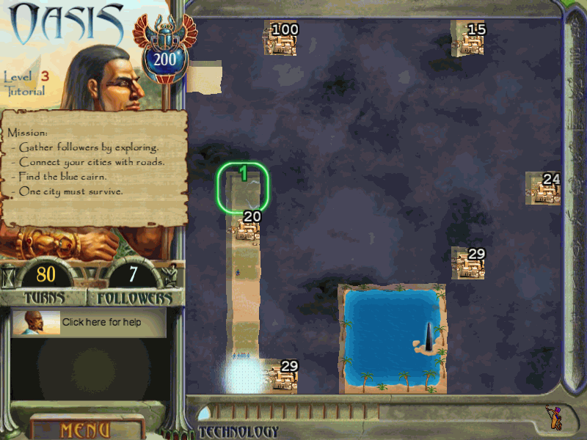

Transport Tycoon: http://www.youtube.com/watch?v=Gyw79aawqxo

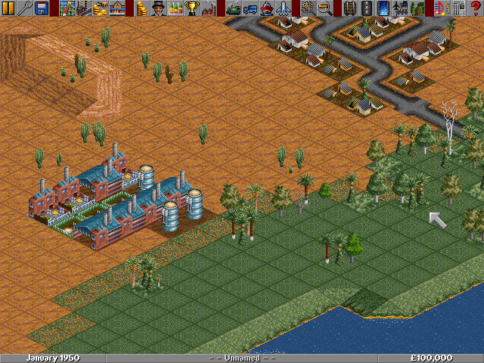

Railroad Tycoon 2: http://www.youtube.com/watch?v=ip7BmnAXYHI

